**Assignment-4**

**Create a private bucket in AWS. Upload a file and check by presigned URL that you can access the file or not.**

# **Steps to follow:-**

## Sign In to AWS:

* + Log in to the [AWS Management Console](https://aws.amazon.com/console/).
  + 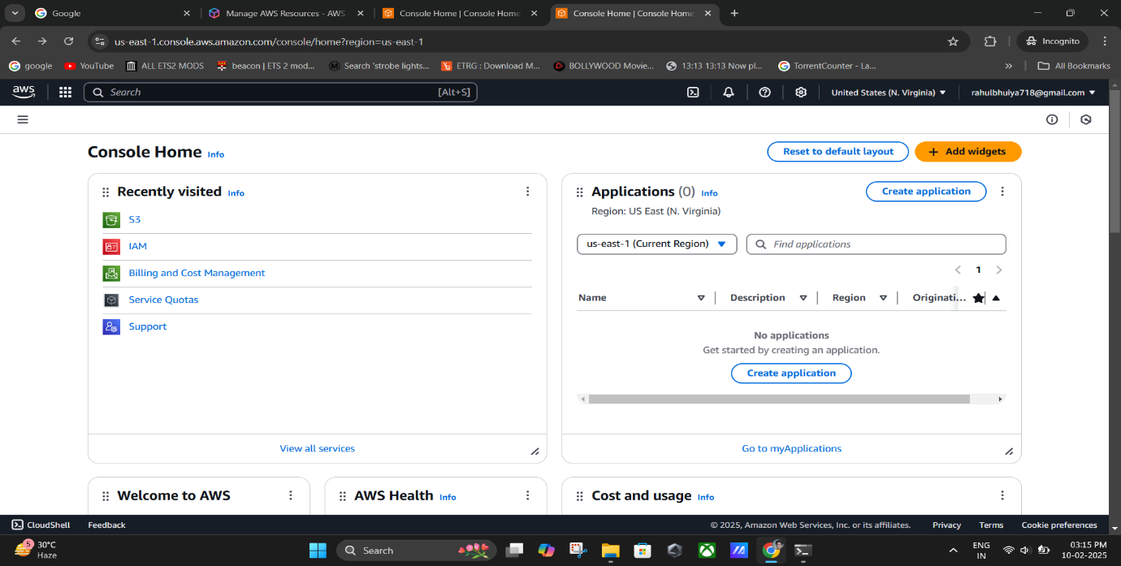Navigate to the **Amazon S3 service** by selecting it from the AWS services list.

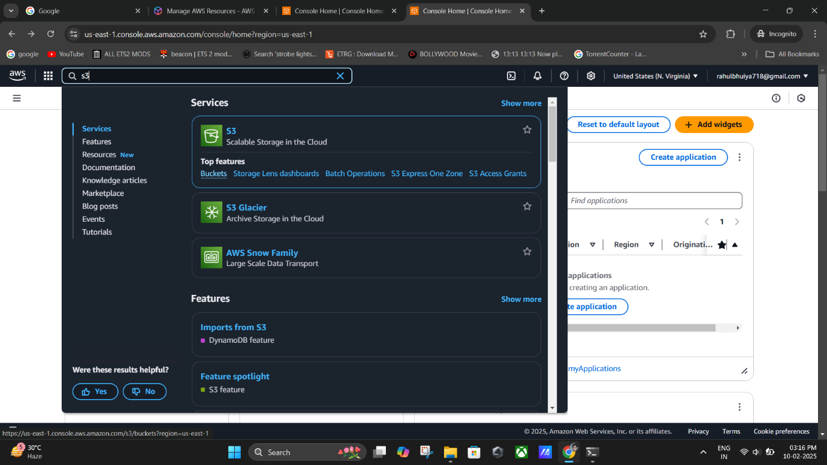

## Create a Private Bucket

1. 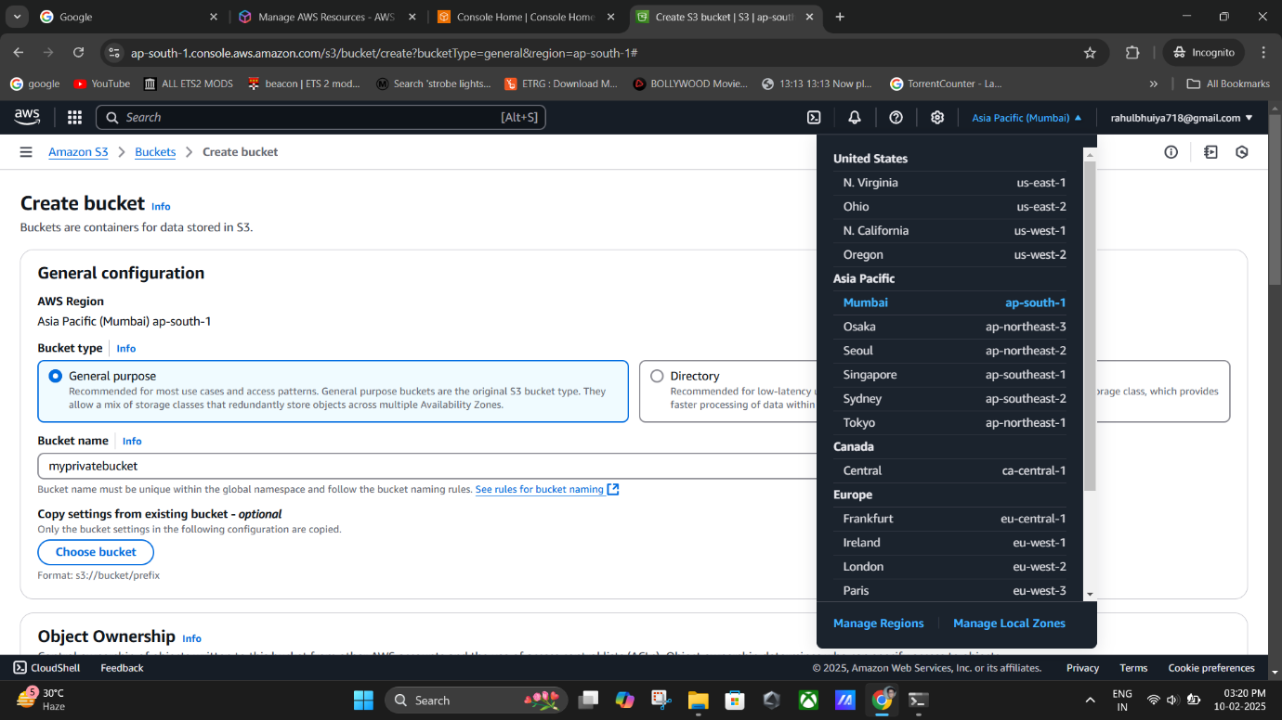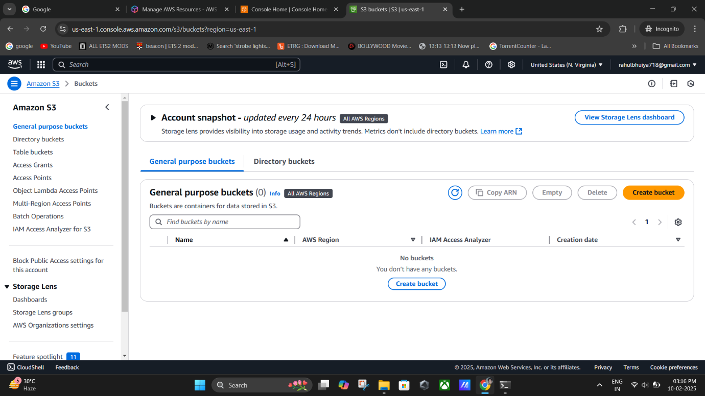In the **S3 console**, click on **Buckets** in the left navigation pane.
2. Select the **Create bucket** button.
3. Provide a unique name for your bucket (e.g., myprivatebucket).
   * Ensure the name:
     + Is unique globally.
     + Has 3-63 characters, including lowercase letters, numbers, dots (.), or hyphens (-).
   * **Remark:** Avoid using dots unless hosting a static website.
4. Select the desired **AWS Region** for your bucket.
5. 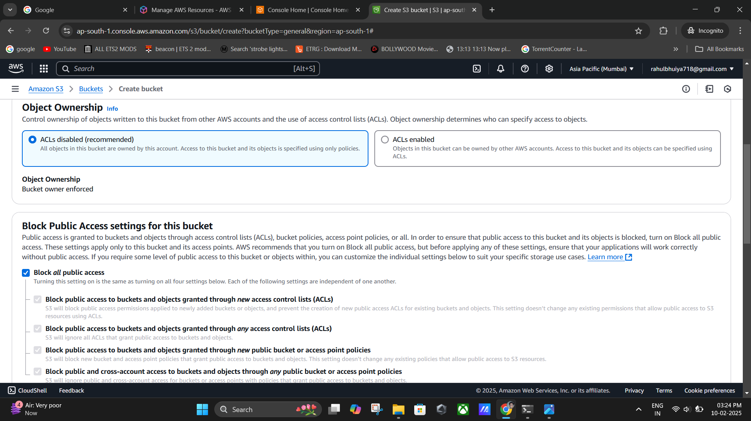Under **Object Ownership**, choose "Bucket owner enforced" to disable ACLs and enforce bucket-level permissions.
6. Enable the **Block Public Access settings** by checking the appropriate checkboxes.
   * **Remark:** This ensures the bucket remains private and inaccessible to the public.



**(Block Public Access settings).**

1. 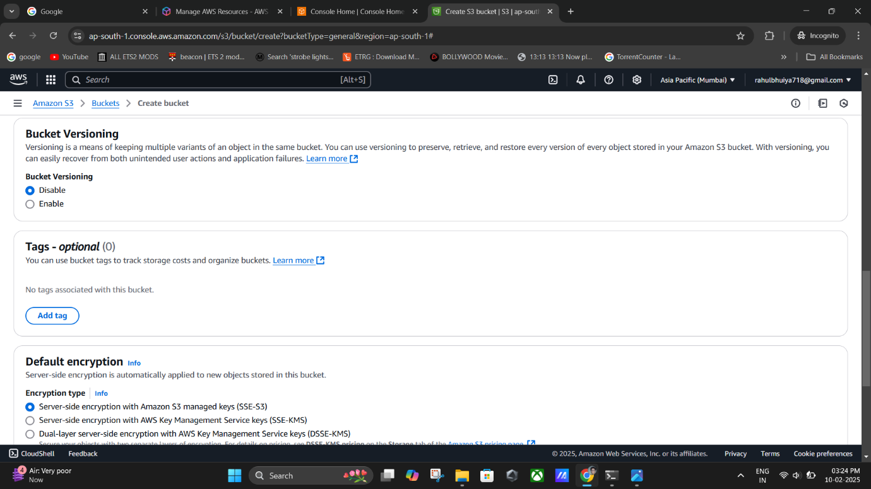Click **Create bucket**.

**(Continuing The Further Steps).**

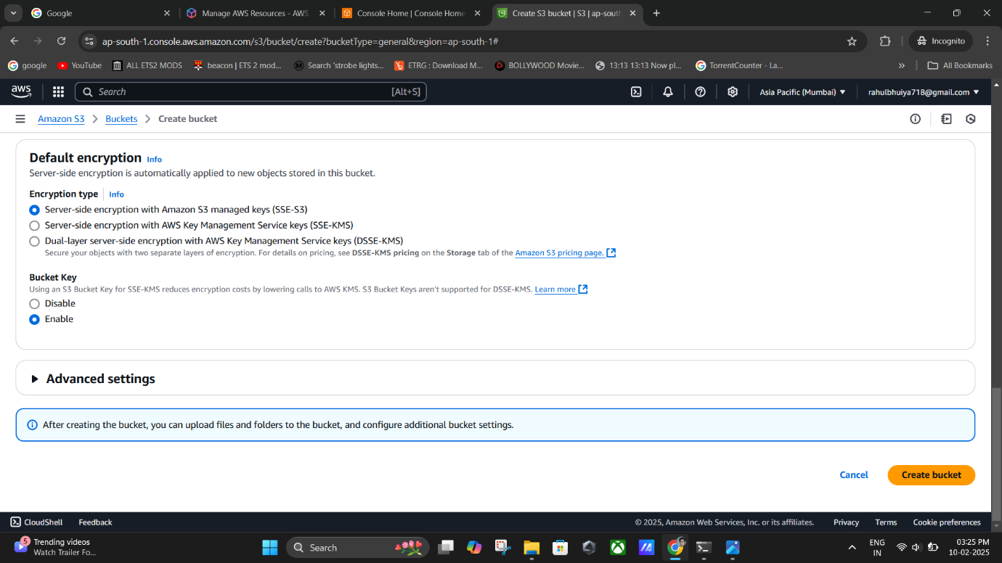

**(Selecting the options for Encryption & Security).**

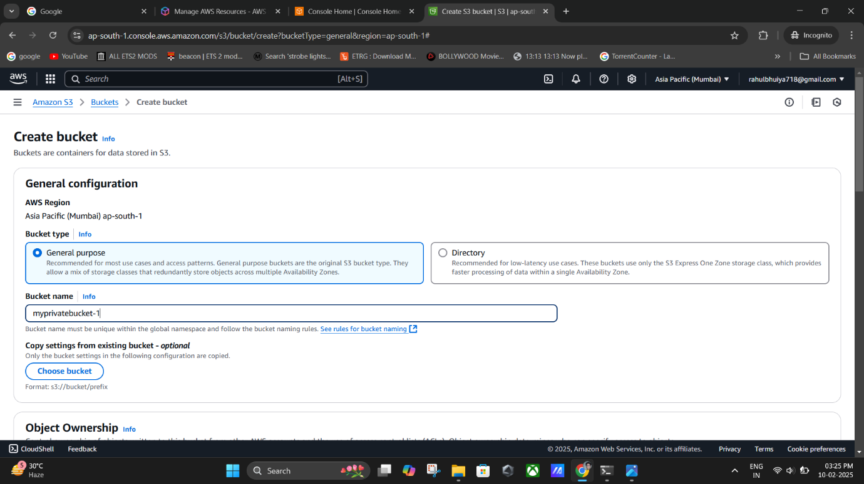

**(Creating my Bucket named as “myprivatebucket-1”)**

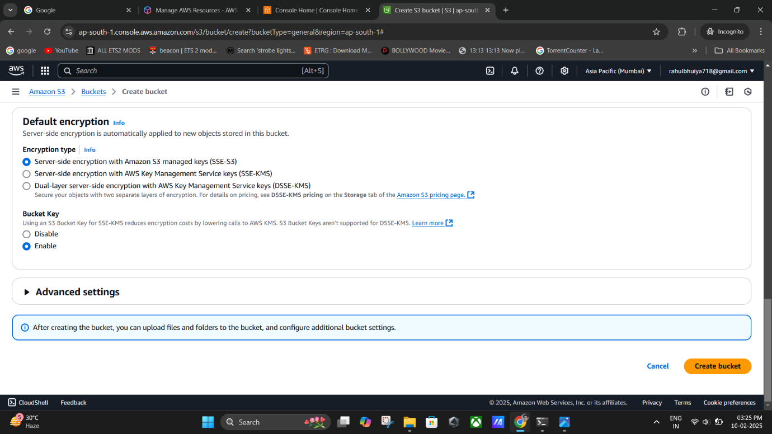

**(Selecting the options for Encryption & Security).**

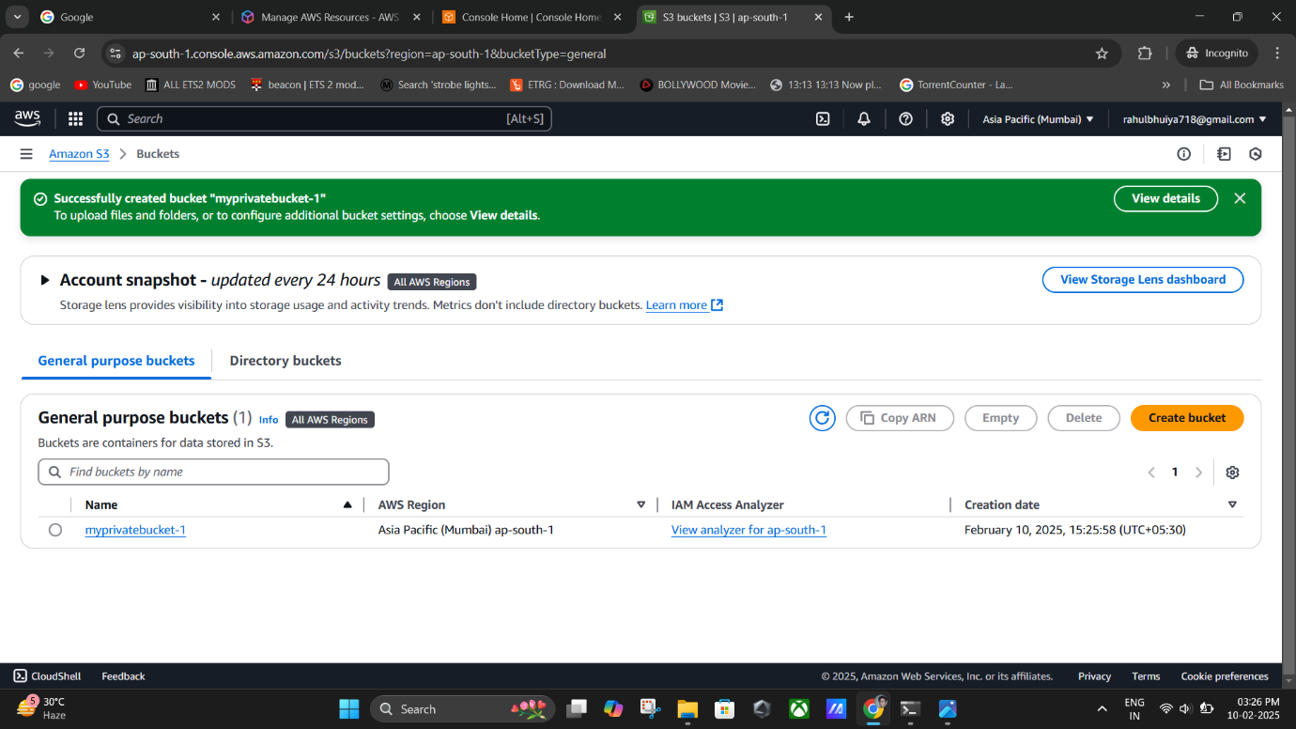

**(“myprivatebucket-1” created successfully).**